服務創新與全球資訊網研討會
Conference on Service Innovation and the World Wide Web

2009年11月27日
November 27, 2009

國立中興大學社館大樓一樓111演講廳
National Chung Hsing University, College of Social Science and Management Building, Conference Room 111, 1st Floor
（台中市國光路250號）
250 Kuo Kuang Road, Taichung 402, Taiwan, R.O.C.

主辦 | Organized by
國立中興大學科技管理研究所 | Graduate Institute of Technology Management, National Chung Hsing University
協辦 | Co-organized by
國立清華大學服務科學研究所 | Institute of Service Science,  National Tsing Hua University
工業技術研究院服務業科技應用中心 | Technology Center For Service Industries, Industrial Technology Research Institute
指導單位 | Sponsored by
行政院國家科學委員會 | National Science Council
國立中興大學 | National Chung Hsing University
服務創新與全球資訊網研討會
Conference on Service Innovation and the World Wide Web
(SIWWW)

Overviews
Over the past decade we have seen the growing market and rising dominance of services to the global economy. According to IBM, services now represent 80% of the US economy. Services account for more than 50% of the economies in countries such as Brazil, Germany, Japan, Russia, and the UK.
Manufacturing has been the major source of Taiwan’s economic competitiveness for many years. Taiwan's service sector was revitalized roughly three decades ago, and in 1988, it began to employ more people than the manufacturing sector. The Department of Industrial Technology (DoIT) of the Ministry of Economic Affairs (MOEA) of Taiwan initiated the Innovative Service R&D Program as a part of the Industrial Technology Development Program in July of 2001 in order to transform Taiwan’s industry from a manufacturing-oriented one to a service and technology-based one. By 2005, about 58.27% of Taiwan's 9.94 million workers were employed in the service sector. In that same year, the sector accounted for 73.33% of Taiwan's GDP, a percentage very similar to that of many advanced nations. In 2007, according to the Directorate-General of Budget, Accounting and Statistics, the service sector contributed 71.05% of total Taiwan's GDP and employing 57.9% of the workforce.
Because of their importance, service science has become a popular field at universities and corporations. Service science is a discipline concerned with finding ways to increase productivity and innovation in services-related industries and tasks by applying scientific means and methods. It’s needed to integrate aspects of established fields such as Computer Science, Operation Research, Engineering, Management Science, Social and Cognitive Sciences to address the theoretical and practical aspects of service business.
Technology has made many services possible, such as those offered by companies like eBay and Google. The swift progress of technology, especially through the websites, allows firms to export their knowledge, creativity, and innovations into global markets and provide services that are previously available only to local customers. The solid ICT (Information and Communications Technology) infrastructure has provided the foundations for the development of an e-enabled “information service economy” in Taiwan. Moreover, service economy is derived not only from traditional service industries, but also from manufacturing and technology industries that have recognized the need to provide revenue-generating quality services in order to compete in the world.
How would service innovation help the companies compete in the new era? Could we apply the internet, a new delivery of services, to developing service science? This conference, held in National Chung Hsing University, is intended to provide a platform for researchers and practitioners to exchange knowledge and perspectives on this emerging field to exploit the potential of service innovation and the application of www.

議程 (Agenda)
場次  Time | 講題及講員  Topics and Speakers | 時間  Duration
9:00-9:30 | 報到 Registration | 30 min.
9:30-9:45 | 開幕致詞  Opening Remarks  林丙輝，國立中興大學社會科學暨管理學院院長  Bing-Huei Lin, Dean, College of Social Science and Management, National Chung-Hsing University  張樹之，國立中興大學科技管理研究所所長  Ernest Chang, Director, Institute of Technology Management, National Chung-Hsing University | 15 min.
9:45-10:45 | 大會主講 Keynote Speech | 60 min.
9:45-10:45 | 講題/Topic:  Exploring Service Science for Knowledge Economy  報告人/Speakers:  徐錚，美國壬色列理工學院決策科學與工程系統學系教授  Cheng Hsu, Professor, Department of Decision Sciences and Engineering Systems, Rensselaer Polytechnic Institute | 60 min.
10:45-11:05 | Coffee / Tea Break | 20 min.
11:05-11:50 | 講題/Topic:  From Smart to Smarter Taiwan: A Service Perspective  報告人/Speakers:  方勇升，工業技術研究院服務業科技應用中心主任  James Fang, General Director, Technology Center for Service Industries, Industrial Technology Research Institute | 45 min.
11:50-12:50 | Lunch | 60 min.
12:50-13:35 | 講題/Topic:  Developing the Industry of Renewable Energy via Intelligent Energy Management Systems  報告人/Speakers:  徐作聖，國立交通大學科技管理研究所教授  Joseph Z. Shyu, Professor, Institute of Management of Technology, National Chiao-Tung University | 45 min.
13:35-14:20 | 講題/Topic:  Apply Service Innovation for Creating a Smarter Planet  報告人/Speakers:  黃振育，IBM GBSC技術經理  Libra Huang, IT Architect, Global Business Solution Centre (GBSC) - Banking, CDL, IBM Taiwan | 45 min.
14:20-14:35 | Coffee / Tea Break | 15 min.
14:35-15:20 | 講題/Topic:  Learning Service Experience from Customer Encounter  報告人/Speakers:  林福仁，清華大學服務科學研究所所長  Fu-Ren Lin, Director, Institute of Service Science, National Tsing-Hua University | 45 min.
15:20-16:20 | 綜合討論 Pannel Discussion  林丙輝院長 張樹之所長 王瑞德教授 謝焸君教授  徐錚教授 方勇升主任 徐作聖教授 黃振育經理 林福仁所長 | 60 min.

聯絡人/Contact Person
黃琬珉 Wan-Min Huang
中興科技管理研究所研究生
Postgraduate, Institute of Technology Management ,National Chung Hsing University
Email: g9826020@mail.nchu.edu.tw
Phone: 0928-048333

國立中興大學路線圖/Location Map of National Chung Hsing University
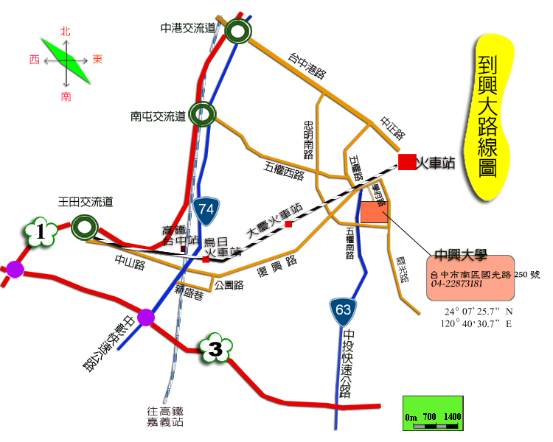

社管大樓校內路線圖/Location Map of Social Science and Management Building
